Core Java:
Features of 1.8
- Functional interfaces
- Lamda expression
- Streaming
- Improved HashMap performance by using Balanced Tree
- Provided jodo date time API as part of java.util.Time package
- The name of JVM PermGen is changed it to Metaspace. Default PermGen maximum size is 64 MB where as Java8 has given Metaspace maximum size is unlimited.

What is functional interface
Functional Interfaces:
- An interface with exactly one abstract method is known as Functional Interface.
- A new annotation @FunctionalInterface has been introduced to mark an interface as Functional Interface.
- @FunctionalInterface annotation is a facility to avoid accidental addition of abstract methods in the functional interfaces.
- If more than on abstract method added then it will throw compile time error
- It enables us to use lambda expressions to instantiate them
- Best example is “Runnable” interface
Default methods:
- Java interface default methods will help us in extending interfaces without having the fear of breaking implementation classes.
- Java interface default methods has bridge down the differences between interfaces and abstract classes.
- Java 8 interface default methods will help us in avoiding utility classes, such as all the Collections class method can be provided in the interfaces itself.
- Java interface default methods will help us in removing base implementation classes, we can provide default implementation and the implementation classes can chose which one to override.
- One of the major reason for introducing default methods in interfaces is to enhance the Collections API in Java 8 to support lambda expressions.
- If any class in the hierarchy has a method with same signature, then default methods become irrelevant. A default method cannot override a method from java.lang.Object. The reasoning is very simple, it’s because Object is the base class for all the java classes. So even if we have Object class methods defined as default methods in interfaces, it will be useless because Object class method will always be used. That’s why to avoid confusion, we can’t have default methods that are overriding Object class methods.
- Java interface default methods are also referred to as Defender Methods or Virtual extension methods.
Static Methods:
- Java interface static method is part of interface, we can’t use it for implementation class objects.
- Java interface static methods are good for providing utility methods, for example null check, collection sorting etc.
- Java interface static method helps us in providing security by not allowing implementation classes to override them.
- We can’t define interface static method for Object class methods, we will get compiler error as “This static method cannot hide the instance method from Object”. This is because it’s not allowed in java, since Object is the base class for all the classes and we can’t have one class level static method and another instance method with same signature.
- We can use java interface static methods to remove utility classes such as Collections and move all of it’s static methods to the corresponding interface, that would be easy to find and use.
If functional interface1, functional interface2 has an abstract method and if it extends then what will happens?
Scenario1:
- If Interace1 and Interface2 has same default method and trying to extend for a same class then it will throw compile time error and enforce to provide definition for the default method.

public class FunctionalInterfaceTest implements Interface1,Interface2
Scenario2:
- If interface1 extends interface and implements by a class then it will not throw any exception
Interface1 extends interface2
public class FunctionalInterfaceTest implements Interface2
Note: In this case always Interface2 default method will override default method of Interface1

Why it is called as Functional Interface
- Function implementations given in Functional Interface that’s why we call them as Functional interfaces
Can functional interface extends another functional interface?
Yes
What is lamda expression?
- Lambda expressions basically express inst=ances of functional interfaces
- lambda expressions implement the only abstract function and therefore implement functional interfaces
- Accessing methods of an interface without creating an object

interface FuncInterface
{
// An abstract function
void abstractFun(int x);
}
// create an internal reference of an interface and calling method
FuncInterface fobj = (int x)->System.out.println(2*x);

// This calls above lambda expression and prints 10.
fobj.abstractFun(5);

Syntax of lamda expression 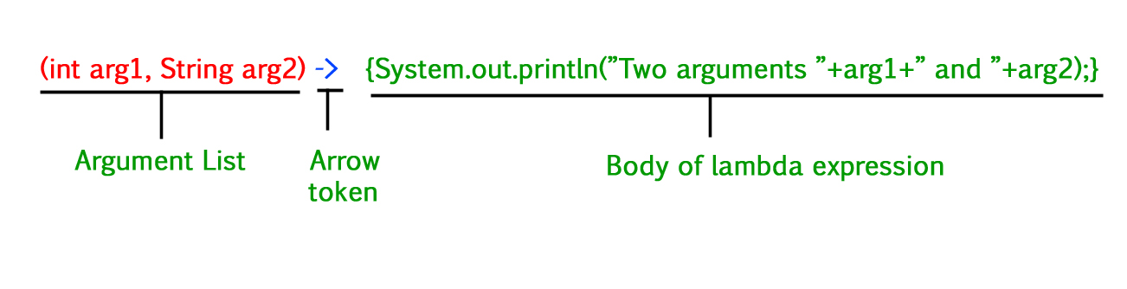
How to print values using lamda expression?
- Zero parameter:
() -> System.out.println("Zero parameter lambda");
- One parameter:–
(p) -> System.out.println("One parameter: " + p);
It is not mandatory to use parentheses, if the type of that variable can be inferred from the context
- Multiple parameters :
(p1, p2) -> System.out.println("Multiple parameters: " + p1 + ", " + p2);
- The body of a lambda expression can contain zero, one or more statements.
- When there is a single statement curly brackets are not mandatory and the return type of the anonymous function is the same as that of the body expression.
- When there are more than one statements, then these must be enclosed in curly brackets (a code block) and the return type of the anonymous function is the same as the type of the value returned within the code block, or void if nothing is returned.

Singleton Vs. Static
1) Static class provides better performance than Singleton pattern, because static methods are bonded on compile time.
2) One more difference between Singleton and static is, ability to override. Since static methods in Java cannot be overridden, they leads to inflexibility. On the other hand, you can override methods defined in Singleton class by extending it.
3) Static classes are hard to mock and consequently hard to test than Singletons, which are pretty easy to mock and thus easy to test. It’s easier to write JUnit test for Singleton than static classes, because you can pass mock object whenever Singleton is expected, e.g. into constructor or as method arguments.
4) If your requirements needs to maintain state than Singleton pattern is better choice than static class, because maintaining state in later case is nightmare and leads to subtle bugs.
5) Singleton classes can be lazy loaded if its an heavy object, but static class doesn't have such advantages and always eagerly loaded.
6) Many Dependency Injection framework manages Singleton quite well e.g. Spring, which makes using them very easy.

What is Java ClassLoader? How ClassLoader Works in Java? What are the class loaders we have in java? How to avoid duplicate class loading?

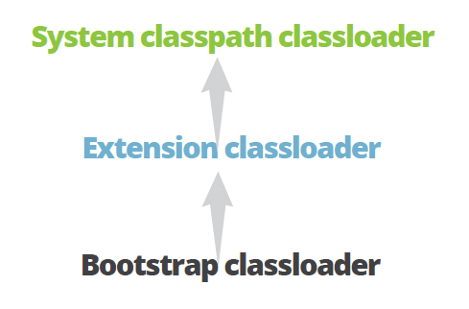
- Bootstrap Class Loader – It loads JDK internal classes. It loads rt.jar and other core classes for example java.lang.* package classes.
- Extensions Class Loader – It loads classes from the JDK extensions directory, usually $JAVA_HOME/lib/ext directory.
- System Class Loader – This classloader loads classes from the current classpath. We can set classpath while invoking a program using -cp or -classpath command line option.
ClassLoader Hierarchy
ClassLoader is hierarchical in loading a class into memory. Whenever a request is raised to load a class, it delegates it to the parent classloader. This is how uniqueness is maintained in the runtime environment. If the parent class loader doesn’t find the class then the class loader itself tries to load the class.

How Java ClassLoader Works?

Let’s understand the working of class loaders from the above program output.
- The java.util.HashMap ClassLoader is coming as null, which reflects Bootstrap ClassLoader. The DNSNameService class ClassLoader is ExtClassLoader. Since the class itself is in CLASSPATH, System ClassLoader loads it.
- When we are trying to load HashMap, our System ClassLoader delegates it to the Extension ClassLoader. The extension class loader delegates it to the Bootstrap ClassLoader. The bootstrap class loader finds the HashMap class and loads it into the JVM memory.
- The same process is followed for the DNSNameService class. But, the Bootstrap ClassLoader is not able to locate it since it’s in $JAVA_HOME/lib/ext/dnsns.jar. Hence, it gets loaded by Extensions Classloader.
- The Blob class is included in the MySql JDBC Connector jar (mysql-connector-java-5.0.7-bin.jar), which is present in the build path of the project. It’s also getting loaded by the System Classloader.
- The classes loaded by a child class loader have visibility into classes loaded by its parent class loaders. So classes loaded by System Classloader have visibility into classes loaded by Extensions and Bootstrap Classloader.
- If there are sibling class loaders then they can’t access classes loaded by each other.
Bootstrap classloader: a new JVM is started the bootstrap classloader is responsible to load key Java classes (from java.lang package) and other runtime classes to the memory first. The bootstrap classloader is a parent of all other classloaders. Consequently, it is the only one without a parent.
Extension classloader: Next comes the extension classloader. It has the bootstrap classloader as parent and is responsible for loading classes from all .jar files kept in the java.ext.dirs path–these are available regardless of the JVM’s classpath.
System classpath classloader: The third and most important classloader from a developer’s perspective is the system classpath classloader, which is an immediate child of the extension classloader. It loads classes from directories and jar files specified by the CLASSPATH environment variable, java.class.path system property or -classpath command line option. ClassLoader is class is given in java.lang.ClassLoader.
Note: Most classloaders delegate finding classes and resources to their parent before searching their own classpath. If the parent classloader cannot find a class or resource, only then does the classloader attempt to find them locally. In effect, a classloader is responsible for loading only the classes not available to the parent; classes loaded by a classloader higher in the hierarchy cannot refer to classes available lower in the hierarchy.

What is permgen memeory? What is Metaspace?
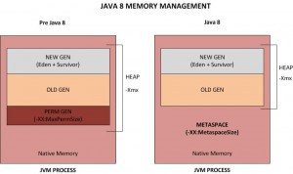
What is PermGen?
Short form for Permanent Generation, PermGen is the memory area in Heap that is used by the JVM to store class and method objects. If your application loads lots of classes, PermGen utilization will be high. PermGen also holds ‘interned’ Strings. The size of the PermGen space is configured by the Java command line option -XX:MaxPermSize Typically 256 MB should be more than enough of PermGen space for most of the applications. However, It is not unusal to see the error “java.lang.OutOfMemoryError: PermGen space“ if you are loading unusual number of classes.

Gone are the days of OutOfMemory Errors due to PermGen space. With Java 8, there is NO PermGen. That’s right. So no more OutOfMemory Errors due to PermGen. The key difference between PermGen and Metaspace is this: while PermGen is part of Java Heap (Maximum size configured by -Xmx option), Metaspace is NOT part of Heap. Rather Metaspace is part of Native Memory (process memory) which is only limited by the Host Operating System.
While you will NOT run out of PermGen space anymore (since there is NO PermGen), you may consume excessive Native memory making the total process size large. The issue is, if your application loads lots of classes (and/or interned strings), you may actually bring down the Entire Server (not just your application). Why ? Because the native memory is only limited by the Operating System. This means you can literally take up all the memory on the Server. Not good.
It is critical that you add the new option -XX:MaxMetaspaceSize which sets the Maximum Metaspace size for your application.
Note that it is no longer sufficient to just monitor the Heap Size. You must also monitor the Metaspace which you can do by just keeping an eye on the ‘process size’ using your Operating System utilities (Example: ‘top’ in Unix/Linux, ‘Task Manager’ in Windows).

- PermGen is an abbreviation for Permanent Generation and it’s a special heap space which is separate from the main Java heap where JVM keeps track of metadata of the classes which have been loaded.
- In Java 8 PermGen has been renamed to Metaspace – with some subtle differences.
- From our perspective, it is important to note that Metaspace has unlimited default maximum size.
- On the contrary, PermGen from Java 7 and earlier has the default maximum size of 64 MB on 32-bit JVM and 82 MB on 64-bit one.
- Of course, these are not the same as the initial sizes. Java 7 and earlier starts with something around 12-21 MB of the initial PermGen space.
JVM | Default maximum PermGen size (MB) | Default maximum Metaspace size
32-bit client JVM | 64 | unlimited
32-bit server JVM | 64 | unlimited
64-bit JVM | 82 | unlimited
It is worthwhile to mention that prior to Java 7, interned Strings used to be kept on the PermGen. That used caused some serious problems with the infamous
java.lang.OutOfMemoryError: PermGen space
- Whenever there is a need to resize PermGen/Metaspace, JVM will do it as it does with the standard heap.
- Resizing those spaces requires a full GC, which is always an expensive operation.
- It can be usually observed during a startup when a lot of classes are being loaded.
- Especially if the application has dependencies on many external libraries. If there are a lot of full GCs during the startup, it’s usually because of that. If that case, increasing the initial size can boost the startup performance.
To increase PermGen, we have the following commands:
-XX:PermSize=N – sets the initial (and minimum size) of the Permanent Generation space
-XX:MaxPermSize=N – sets the maximum size of the Permanent Generation space
In Java 8 and onwards, we can set the initial and maximum size of Metaspace using the following commands:
-XX:MetaspaceSize=N – sets the initial (and minimum size) of the Metaspace
-XX:MaxMetaspaceSize=N – sets the maximum size of the Metaspace
Note: The size of Heap is 512MB by default
When will u get 'OutOfmemeoryexception' and explain internal memory management and how to resolve it?
In Java, all objects are stored in the heap. They are allocated using new operator. The OutOfMemoryError Exception in Java looks like this:
Exception in thread "main" java.lang.OutOfMemoryError: Java heap space
Usually, this error is thrown when the Java Virtual Machine cannot allocate an object because it is out of memory, and no more memory could be made available by the garbage collector.
OutOfMemoryError usually means that you’re doing something wrong,
- Holding onto objects too long, or trying to process too much data at a time.
- Sometimes, it indicates a problem that’s out of your control, such as a third-party library that caches strings, or an application server that doesn’t clean up after deploys.
- And sometimes, it has nothing to do with objects on the heap.
Java heap space will throw OutOfMemoryError when:
- This error arises due to the applications that make excessive use of finalizers. If a class has a finalize method, then objects of that type do not have their space reclaimed at garbage collection time. Instead, after garbage collection, the objects are queued for finalization, which occurs at a later time. Implementation:
- finalizers are executed by a daemon thread that services the finalization queue.
- If the finalizer thread cannot keep up, with the finalization queue, then the Java heap could fill up and this type of OutOfMemoryError exception would be thrown.
- The problem can also be as simple as a configuration issue, where the specified heap size (or the default size, if it is not specified) is insufficient for the application.

PermGen space will throw OutOfMemoryError when:
- Java memory is separated into different regions. The size of all those regions, including the permgen area, is set during the JVM launch. If you do not set the sizes yourself, platform-specific defaults will be used.
- The java.lang.OutOfMemoryError: PermGen space error indicates that the Permanent Generation’s area in memory is exhausted.
- new classes keep on generating and loading their definitions into Permgen space until the space is fully utilized and the java.lang.OutOfMemoryError: Permgen space is thrown.
- Prevention: When the OutOfMemoryError due to PermGen exhaustion is caused during the application launch, the solution is simple. The application just needs more room to load all the classes to the PermGen area so we just need to increase its size. To do so, alter your application launch configuration and add (or increase if present) the -XX:MaxPermSize parameter similar to the following example.
Metaspace space will throw OutOfMemoryError when:
- Java class metadata is allocated in native memory. If metaspace for class metadata is exhausted, a java.lang.OutOfMemoryError exception with a detail MetaSpace is thrown.
- The amount of metaspace that can be used for class metadata is limited by the parameter MaxMetaSpaceSize, which is specified on the command line. When the amount of native memory needed for a class metadata exceeds MaxMetaSpaceSize, a java.lang.OutOfMemoryError exception with a detail MetaSpace is thrown.
- This code will keep generating new classes and loading their definitions to Metaspace until the space is fully utilized and the java.lang.OutOfMemoryError: Metaspace is thrown. When launched with -XX:MaxMetaspaceSize=64m then on Mac OS X my Java 1.8.0_05 dies at around 70, 000 classes loaded.
- Prevention : If MaxMetaSpaceSize, has been set on the command-line, increase its value. MetaSpace is allocated from the same address spaces as the Java heap. Reducing the size of the Java heap will make more space available for MetaSpace. This is only a correct trade-off if there is an excess of free space in the Java heap.
Requested array size exceeds VM limit :
- This error indicates that the application attempted to allocate an array that is larger than the heap size. For example, if an application attempts to allocate an array of 1024 MB but the maximum heap size is 512 MB then OutOfMemoryError will be thrown with “Requested array size exceeds VM limit”.
Integer[] array = new Integer[10000 * 10000];

How to improved JVM performance?

How to create immutable class?
- Make class as final
- Make all properties as final
- Have only getter methods and don’t write set methods
- Have parameterized constructor to assign values to its properties
https://howtodoinjava.com/java/basics/how-to-make-a-java-class-immutable/

Garbage Collection(GC)
https://howtodoinjava.com/java/garbage-collection/all-garbage-collection-algorithms/

Collections:
How HashMap works internally?
https://howtodoinjava.com/java/collections/hashmap/how-hashmap-works-in-java/
Synchronization – Class level and Object level locking
https://howtodoinjava.com/java/multi-threading/object-vs-class-level-locking/
wait(), notify(),notifyAll()
https://howtodoinjava.com/java/multi-threading/wait-notify-and-notifyall-methods/
ThreadPoolExecutor
https://howtodoinjava.com/java/multi-threading/java-thread-pool-executor-example/

TimeCompexcity O(log n) means?
https://hackernoon.com/what-does-the-time-complexity-o-log-n-actually-mean-45f94bb5bfbf
Big-O notation
O(1) an operation which is done to reach an element directly (like a dictionary or hash table)
O(n) means first we would have to search it by checking n elements
O(log n) O(n) or O(log n) is better, consider: if n = 1000, then log n = 3 (for log-base-10). Which would you rather have your algorithm take to run: 1000 seconds, or 3 seconds?
Imagine a classroom of 100 students in which you gave your pen to one person. Now, you want that pen. Here are some ways to find the pen and what the O order is.

O(n): Going and asking each student individually is O(N).
O(log n): Now I divide the class into two groups, then ask: “Is it on the left side, or the right side of the classroom?” Then I take that group and divide it into two and ask again, and so on. Repeat the process till you are left with one student who has your pen. This is what you mean by O(log n).

#include <stdio.h>
int main()
{
printf("Hello World");
}
In above code “Hello World!!!” print only once on a screen. So, time complexity is constant: O(1) i.e. every time constant amount of time require to execute code, no matter which operating system or which machine configurations you are using.

void main()
{
int i, n = 8;
for (i = 1; i <= n; i++) {
printf("Hello Word !!!");
}
}
In above code “Hello World!!!” will print N times. So, time complexity of above code is O(N).

Java Sorting:
https://howtodoinjava.com/java-sorting-guide/
Java concurrency:
https://howtodoinjava.com/java-concurrency-tutorial/
Java Synchronization
https://howtodoinjava.com/java/keywords/java-synchronized/

Diff between Hashtable and HashMap?
HashTable:
- One of the collection class
- It will store data in Key, Value format
- It will not allow null Key
- It will not allow null Value
- Hash table internally uses HashMap
- HashTable is threadsafe
- HashTable performance is bit slow when compare with HashMap
- Iterator in HashTable is fail-safe.
HashMap:
- One of the collection class
- It will store data in Key,Value format
- HashMap is not threadsafe
- Since HashMap is not synchronized it performs better
- Hashmap allows 1 null key & several null values
- Iterator in hashmap is fail-fast.
- In multiple threaded environment HashMap is usually faster than ConcurrentHashMa
- HashMap can be make it as synchronized by using Collections.synchronizedMap(HashMap);

Note: Fail-fast means if one thread is iterating over a map and another is trying to modify it by adding/deleting elements, it will throw ConcurrentModificationException.

What is the difference between HashMap and ConcurrentHashMap?
ConcurrentHashMap:
- It stores data in Key,Value paire
- It will not allow Null key or Null value
- It is suitable in multithreaded environment
- It synchronizes or locks on the certain portion of the Map. To optimize the performance of ConcurrentHashMap, Map is divided into different partitions depending upon the Concurrency level. So that we do not need to synchronize the whole Map Object.
- Thread-safe, Synchronization, Null Key and Performance
- The underlined data structure for ConcurrentHashMap is Hashtable.
- ConcurrentHashMap class is thread-safe i.e. multiple thread can operate on a single object without any complications.
- At a time any number of threads are applicable for read operation without locking the ConcurrentHashMap object which is not there in HashMap.
- In ConcurrentHashMap, the Object is divided into number of segments according to the concurrency level.
- Default concurrency-level of ConcurrentHashMap is 16.
- In ConcurrentHashMap, at a time any number of threads can perform retrieval operation but for updation in object, thread must lock the particular segment in which thread want to operate.This type of locking mechanism is known as Segment locking or bucket locking.Hence at a time 16 updation operations can be performed by threads.
- null insertion is not possible in ConcurrentHashMap as key or value.

- ConcurrentHashMap m=new ConcurrentHashMap();:Creates a new, empty map with a default initial capacity (16), load factor (0.75) and concurrencyLevel (16).
- ConcurrentHashMap m=new ConcurrentHashMap(int initialCapacity);:Creates a new, empty map with the specified initial capacity, and with default load factor (0.75) and concurrencyLevel (16).
- ConcurrentHashMap m=new ConcurrentHashMap(int initialCapacity, float loadFactor);:
Creates a new, empty map with the specified initial capacity and load factor and with the default concurrencyLevel (16).
- ConcurrentHashMap m=new ConcurrentHashMap(int initialCapacity, float loadFactor, int concurrencyLevel);:Creates a new, empty map with the specified initial capacity, load factor and concurrency level.

Diff. between HashTable and ConcurrentHashMap?
- The difference between Hashtable and ConcurrentHashMap, both can be used in the multithreaded environment but once the size of Hashtable becomes considerable large performance degrade because for iteration it has to be locked for a longer duration.
- Since ConcurrentHashMap introduced the concept of segmentation, how large it becomes only certain part of it get locked to provide thread safety so many other readers can still access map without waiting for iteration to complete.
- ConcurrentHashMap only locked certain portion of Map while Hashtable locks full map while doing iteration.
What is Fail Safe and Fail-Fast(HashMap is the example) and Fail-Safe(ConcurrentHashMap is the example)?
- HashMap is fail-fast
- ConccurentHashMap and HashTable are fail-safe
How ConcurrentHashMap will work internatelly?

What are methods you should override when you put an object as key in HashMap?

You need to implement hashcode() and equals() method if you put key as object in HashMap.

Why java uses another hash function internally to calculate hash value apart from hashcode method which you have implemented?
It is due to avoid large number of collisions due to bad hashcode method written by developers.
What if you don’t override hashcode method while putting custom objects as key in HashMap?
As we did not implement hashcode method, each object will have different hashcode(memory address) by default, so even if we have implemented equals method correctly, it won’t work as expected.

What are differences between HashMap and HashSet in java?
Parameter | HashMap | HashSet
Interface | This is core difference among them.HashMap implements Map interface | HashSet implement Set interface
Method for storing data | It stores data in a form of key->value pair.So it uses put(key,value) method for storing data | It uses add(value) method for storing data
Duplicates | HashMap allows duplicate value but not duplicate keys | HashSet does not allow duplicate values.
Performance | It is faster than hashset as values are stored with unique keys | It is slower than HashMap
HashCode Calculation | In hash map hashcode value is calculated using key object | In this,hashcode is calculated on the basis of value object. Hashcode can be same for two value object so we have to implement equals() method.If equals() method return false then two objects are different.

What are differences between ArrayList and LinkedList in java?

Parameter | ArrayList | LinkedList
Internal data structure | It uses dynamic array to store elements internally | It uses doubly Linked List to store elements internally
Manipulation | If We need to insert or delete element in ArrayList, it may take O(n), as it internally uses array and we may have to shift elements in case of insertion or deletion | If We need to insert or delete element in LinkedList, it will take O(1), as it internally uses doubly LinkedList
Search | Search is faster in ArrayList as uses array internally which is index based. So here time complexity is O(1) | Search is slower in LinkedList as uses doubly Linked List internally So here time complexity is O(n)
Interfaces | ArrayList implements List interface only, So it can be used as List only | LinkedList implements List,Deque interfaces, so it can be used as List,Stack or Queue

Comparable VS Comparator
Parameter | Comparable | Comparator
Sorting logic | Sorting logic must be in same class whose objects are being sorted. Hence this is called natural ordering of objects | Sorting logic is in separate class. Hence we can write different sorting based on different attributes of objects to be sorted. E.g. Sorting using id,name etc.
Implementation | Class whose objects to be sorted must implement this interface.e.g Country class needs to implement comparable to collection of country object by id | Class whose objects to be sorted do not need to implement this interface.Some other class can implement this interface. E.g.-CountrySortByIdComparator class can implement Comparator interface to sort collection of country object by id
Sorting method | int compareTo(Object o1)  This method compares this object with o1 object and returns a integer.Its value has following meaning  1. positive – this object is greater than o1  2. zero – this object equals to o1  3. negative – this object is less than o1 | int compare(Object o1,Object o2)  This method compares o1 and o2 objects. and returns a integer.Its value has following meaning.  1. positive – o1 is greater than o2  2. zero – o1 equals to o2  3. negative – o1 is less than o1
Calling method | Collections.sort(List)  Here objects will be sorted on the basis of CompareTo method | Collections.sort(List, Comparator)  Here objects will be sorted on the basis of Compare method in Comparator
Package | Java.lang.Comparable | Java.util.Comparator

What data structure will be used by HashTable, HashMap and ConcurrentHashMap?
ArrayList Dynamic Arrays
HashSet HashMap
HashTable Singly Linked List also called as Buckets
HashMap Singly Linked List also called as Buckets
ConcurrentHashMap Singly Linked List(8) and Balanced Trees
LinkedHashMap Singly Linked List
LinkedHashSet LinkedHashMap
TreeSet
NavigableTreeSet

What is the effective way to Overrride equals() method in java?
public class EffectiveEquals {
private int valueA;
private int valueB;
. . .
public boolean equals( Object o ) {
if(this == o) { // Step 1: Perform an == test
return true;
}
if(!(o instanceof EffectiveEquals)) { // Step
2: Instance of check
return false;
}
EffectiveEquals ee = (EffectiveEquals) o; //
Step 3: Cast argument
// Step 4: For each important field, check to
see if they are equal
// For primitives use ==
// For objects use equals() but be sure to also
// handle the null case first
return ee.valueA == valueA &&
ee.valueB == valueB;
}
. . .
}

What is Collision?
If multiple objects may map to the same bucket in HashTable or HashMap, an event known as a collision
How to sort a Map? explain the code?
- Comparable: Comparing with single property. Class should implements Comparable interface and override compateTo(Object obj) method.
- Comparator: Comparing with multiple properties. Create separate class and implements Comparator and override compare(Object obj,Object obj1) method.
How to create a singleton class?
- Define class with private constructor
- Define classreference as static
- Define getInstance(): check with null, create and return object
how to create an object of a private constructor class?
- Using singleton design pattern
We can create an object of a singleton class using Reflection API? how to do it and how to avoid it?
How LinkedHashSet Works Internally In Java? How ordered collection maintain insertion order? exaplain?
boolean b1 = hs.add("Geeks"); True
boolean b2 = hs.add("GeeksforGeeks"); True

// adding duplicate element
boolean b3 = hs.add("Geeks"); False

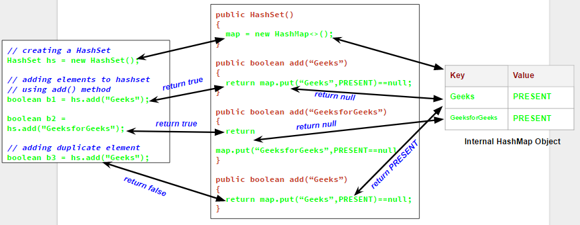

- Add() method checks whether the set already contains the specified element or not
- Look at the internal implementation of the add() method from Java API
Public Boolean add(E e)
{
Return map.put(e,PRESENT)==null;
}
Note: PRESENT is the dummy variable defined in the HashSet class.
- Whenever we create a HashSet, it internally creates a HashMap and if we insert an element into this HashSet using add() method, it actually call put() method on internally created HashMap object with element you have specified as it’s key and constant Object called “PRESENT” as it’s value.
- A Set achieves uniqueness internally through HashMap.
- As we know in a HashMap each key is unique and when we call put(Key, Value) method, it returns the previous value associated with key, or null if there was no mapping for key.
- In add() method we check the return value of map.put(key, value) method with null value.
- If map.put(key, value) returns null, then the statement “map.put(e, PRESENT) == null” will return true and element is added to the HashSet(internally HashMap).
- If map.put(key, value) returns old value of the key, then the statement “map.put(e, PRESENT) == null” will return false and element is not added to the HashSet(internally HashMap).
- As LinkedHashSet extends HashSet, so it internally calls constructors of HashSet using super(). Similarly creating an object of TreeSet class internally creates object of Navigable Map as backing map.
Why do I need to override the equals and hashCode methods in Java?
- On runtime, JVM computes hash code for each object and provide it on demand. When we modify an object’s state, JVM set a flag that object is modified and hash code must be AGAIN computed. So, next time you call object’s hashCode() method, JVM recalculate the hash code for that object.
- Collections such as HashMap and HashSet use a hashcode value of an object to determine how it should be stored inside a collection, and the hashcode is used again in order to locate the object in its collection.
Hashing retrieval is a two-step process:
- Find the right bucket (using hashCode()) – returns the hashcode of an object
- Search the bucket for the right element (using equals() ) – compare both objects based on logic specified in equals() method

Contract: If equals() and hashCode() method should return same value.

public boolean equals(Object obj) {
if (obj == this)
return true;
if (!(obj instanceof Employee))
return false;
Employee employee = (Employee) obj;
return employee.getAge() == this.getAge()
&& employee.getName() == this.getName();
}

@Override
public int hashCode() {
int result=17;
result=31*result+age;
result=31*result+(name!=null ? name.hashCode():0);
return result;
}

Note: If any one of the above method is commented then it will return false for equals operation even though both are equal.

How to make employee object as a Key in HashMap, what are the things need to be taken care?
- Define class as final
- Override equals() and hasCode() methods

The contract between hashCode() and equals()
- Whenever a.equals(b) is true, then a.hashCode() must be same as b.hashCode().
- Whenever a.equals(b) is false, then a.hashCode() may/may not be same as b.hashCode().
HashMap key object immutable

How to Access All Private Fields, Methods and Constructors using Java Reflection with Example and how to overcome this?
What sorting technique used by Collections.sort() method and what is internal algorithm?
Collection.sort() – Uses MergeSort [works by calling the underlying Arrays.sort() method, while the sorting itself uses Insertion Sort for arrays shorter than 47, and Quicksort for the rest.]
Arrays.sort() – uses QuickSort
Note: In latest version both are using TimSort.

Quicksort
Quicksort is another Divide and Conquer algorithm. It picks one element of an array as the pivot and sorts all of the other elements around it, for example smaller elements to the left, and larger to the right.
This guarantees that the pivot is in its proper place after the process. Then the algorithm recursively does the same for the left and right portions of the array.
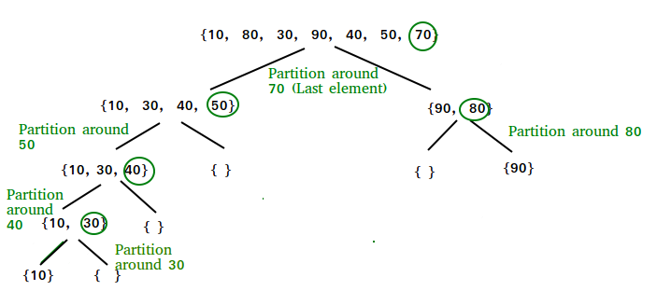
Merge Sort:
Merge Sort is a Divide and Conquer algorithm. It divides input array in two halves, calls itself for the two halves and then merges the two sorted halves. The merge() function is used for merging two halves.
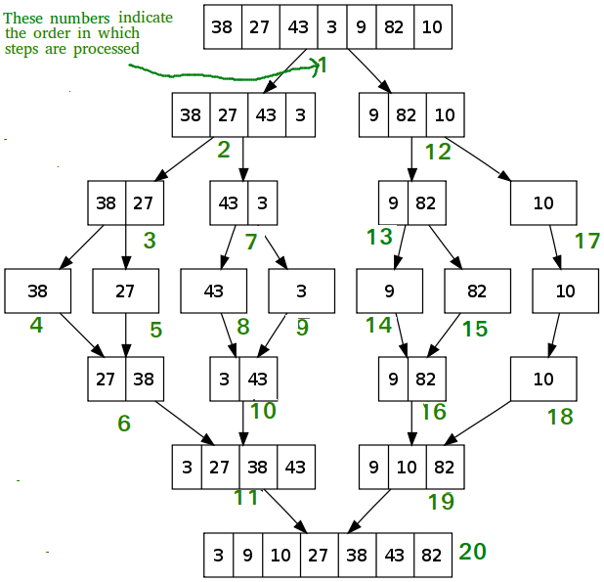
How to create Immutable list in java?
- ImmutableList, as suggested by the name, is a type of List which is immutable. It means that the content of the List are fixed or constant after declaration, that is, they are read-only.
- If any attempt made to add, delete and update elements in the List, UnsupportedOperationException is thrown.
- An ImmutableList does not allow null element either.
- If any attempt made to create an ImmutableList with null element, NullPointerException is thrown. If any attempt is made to add null element in List, UnsupportedOperationException is thrown.
Advantages of ImmutableList
- They are thread safe.
- They are memory efficient.
- Since they are immutable, hence they can be passed over to third party libraries without any problem.
Note that it is an immutable collection, not collection of immutable objects, so the objects inside it can be modified.

List<String> list = new ArrayList<>();
list.add("Geeks");

// Create ImmutableList from List using copyOf()
List<String> iList = Collections.unmodifiableList(list);

// We change List and the changes reflect in iList.
list.add("For"); // Valid and no exception

// We can not modify the iList directly
iList.add("abc"); // It will throw exception UnsupportedOperationException

Difference between Association, Composition and Aggregation in Java
- Association means two objects are related to each other but can exist without each other
- Composition is a form of association where one object is composed of multiple objects, but they only exists together e.g. human body is the composition of organs, individual organs cannot live they only useful in the body.
- Aggregation is a collection of object e.g. city is an aggregation of citizens.
What is Immutable in java?
- String is immutable in java
- To make it Thread Safe
- Value can not be modified – security
What is basic principle abstraction in java?
Datastructures: Stack, Queue and SLL with basic program
How to clone an object in java?
- Class should be implements Clonable interface
- Override clone method
What sorting algorithms you know and implemented?
Diff. Between Comparable and Comparator
Comparable | Comparator
1) Comparable provides a single sorting sequence. In other words, we can sort the collection on the basis of a single element such as id, name, and price. | The Comparator provides multiple sorting sequences. In other words, we can sort the collection on the basis of multiple elements such as id, name, and price etc.
2) Comparable affects the original class, i.e., the actual class is modified. | Comparator doesn't affect the original class, i.e., the actual class is not modified.
3) Comparable provides compareTo() method to sort elements. | Comparator provides compare() method to sort elements.
4) Comparable is present in java.lang package. | A Comparator is present in the java.util package.
5) We can sort the list elements of Comparable type by Collections.sort(List) method. | We can sort the list elements of Comparator type by Collections.sort(List, Comparator) method.

What is a couple of ways to resolve collision in the hash table?
linear probing, double hashing, and chaining. In linear probing, if the bucket is already occupied then function check next bucket linearly until it finds an empty one, while in chaining, multiple elements are stored in same bucket location.

What is lazy and early loading of Singleton and how will you implement it?

Answer : As there are many ways to implement Singleton like using double checked locking or Singleton class with static final instance initialized during class loading. Former is called lazy loading because Singleton instance is created only when client calls getInstance() method while later is called early loading because Singleton instance is created when class is loaded into memory.

Give me some examples of Singleton pattern from Java Development Kit?
Answer to this question is java.lang.Runtime
There are many classes in Java Development Kit which is written using singleton pattern, here are few of them:
- Java.lang.Runtime with getRuntime() method
- Java.awt.Toolkit with getDefaultToolkit()
- Java.awt.Desktop with getDesktop()

What is double checked locking in Singleton?
Answer : Double checked locking is a technique to prevent creating another instance of Singleton when call to getInstance() method is made in multi-threading environment. In Double checked locking pattern as shown in below example, singleton instance is checked two times before initialization. See here to learn more about double-checked-locking in Java.

public static Singleton getInstance(){
if(_INSTANCE == null){
synchronized(Singleton.class){
//double checked locking - because second check of Singleton instance with lock
if(_INSTANCE == null){
_INSTANCE = new Singleton();
}
}
}
return _INSTANCE;
}
Double checked locking should only be used when you have requirement for lazy initialization otherwise use Enum to implement singleton or simple static final variable.

How do you prevent for creating another instance of Singleton using reflection?
Answer: This is similar to previous interview question. Since constructor of Singleton class is supposed to be private it prevents creating instance of Singleton from outside but Reflection can access private fields and methods, which opens a threat of another instance. This can be avoided by throwing Exception from constructor as “Singleton already initialized”
Read more: https://javarevisited.blogspot.com/2011/03/10-interview-questions-on-singleton.html#ixzz5diJ2ffiz

Threads:
Explain about multi-threaded environment in java?

What is a critical section?
A critical section is the part of a code, which is very important and in multi-threading must be exclusively modified by any thread. Semaphore or mutex is used to protect critical section. In Java, you can use synchronized keyword or ReentrantLock to protect a critical section.
What is Executor Framework? - what are the 4 ways to create it.
- It maintains thread pooling.
- The Java ExecutorService interface, java.util.concurrent.ExecutorService, represents an asynchronous execution mechanism which is capable of executing tasks concurrently in the background.
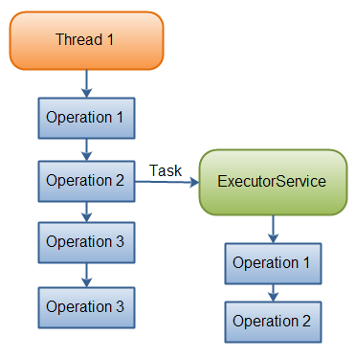

- Create ExecutorService instance with fixed number of threads. We can create in 4 ways:

  - ExecutorService es = ExecutorService.newFixedThreadPool(10);

  - newSingleThreadExecutor()

  - newWorkStealingPool(): This factory method is part of Java 8 and returns an executor of type ForkJoinPool which works slightly different than normal executors. Instead of using a fixed size thread-pool ForkJoinPools are created for a given parallelism size which per default is the number of available cores of the hosts CPU. ForkJoinPools exist since Java 7.

  - Schedule ExecutorService:
ScheduledExecutorService executor = Executors.newScheduledThreadPool(1);

- Submit request to the ExecutorService

es.submit(new Callable(){

public Object call(){
return …?
}
});
- To maintain the status of a particular submitted thread, then use Future object. The ExecutorService returns a Future, an object that has a reference to the task we handed over to the ExecutorService.

Future ft = es.submit(new Callable(){

public Object call(){
return …?
}
});
- To get the status of the Thread. Use Future object reference and get() method. It will interrupt the existing thread and will return the status.
ft.get();
To stop ExecutorService, it has 2 methods:
- shutdown(): Wait to complete running tasks to be completed
- shutdownNow(): Interrupts all running tasks and shut the executor down immediately
After submitting the callable to the executor we first check if the future has already been finished execution via isDone()
Executors support batch submitting of multiple callables at once via invokeAll(). This method accepts a collection of callables and returns a list of futures.
Another way of batch-submitting callables is the method invokeAny() which works slightly different to invokeAll(). Instead of returning future objects this method blocks until the first callable terminates and returns the result of that callable.

Scheduled Executors:
In order to periodically run common tasks multiple times, we can utilize scheduled thread pools.
A ScheduledExecutorService is capable of scheduling tasks to run either periodically or once after a certain amount of time has elapsed.
This code sample schedules a task to run after an initial delay of three seconds has passed:
ScheduledExecutorService executor = Executors.newScheduledThreadPool(1);
Runnable task = () -> System.out.println("Scheduling: " + System.nanoTime());
ScheduledFuture<?> future = executor.schedule(task, 3, TimeUnit.SECONDS);
TimeUnit.MILLISECONDS.sleep(1337);
long remainingDelay = future.getDelay(TimeUnit.MILLISECONDS);

Summary of task execution methods
 | Call from non-fork/join clients | Call from within fork/join computations
Arrange async execution | execute(ForkJoinTask) | ForkJoinTask.fork()
Await and obtain result | invoke(ForkJoinTask) | ForkJoinTask.invoke()
Arrange exec and obtain Future | submit(ForkJoinTask) | ForkJoinTask.fork() (ForkJoinTasks are Futures)

How to asynchronously call a method in Java using Thread?
There are lot of ways to declare a thread in java.
But to use Thread for only calling methods in background or once in a program.
Then the most preferable way is to use anonymous classes.
Anonymous classes enable you to make your code more concise.
They enable you to declare and instantiate a class at the same time.
They are like local classes except that they do not have a name.
Use Anonymous classes if you need to use a local class only once.

new Thread( new Runnable() {
public void run(){
** CALL METHOD FOR WORK IN BACKGROUND **
}
}).start();

When this thread get started then it will execute in background.
and when run method of thread will fire than it will call your method for background work.
And it will not stop or delay your rest program.
But now the question arises that when will thread Stop ?
Thread will not stop itself. it will remain live until application not close.
So, to kill or make the thread stop we will return in run method of that thread.
But run() is of void type can't return any value . So we will just call return; in Run() method .
We will write return; in run after calling of methods for background work.
new Thread( new Runnable() {

public void run(){

sendMail();** CALL METHOD FOR WORK IN BACKGROUND **

return; // to stop the thread
}
}).start();

What is ThreadGroup and its different names
1 | ThreadGroup(String name)  This constructs a new thread group.
2 | ThreadGroup(ThreadGroup parent, String name)  This creates a new thread group.

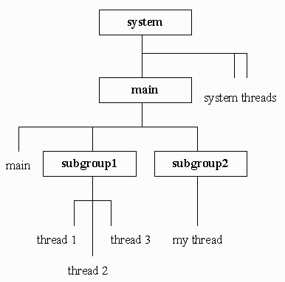

system—to join some other thread group. That arrangement leads to a hierarchical thread-group structure, which the figure below illustrates in an application context.
At the top of the figure's structure is the system thread group. The JVM-created system group organizes JVM threads that deal with object finalization and other system tasks, and serves as the root thread group of an application's hierarchical thread-group structure. Just below system is the JVM-created main thread group, which is system's subthread group (subgroup, for short). main contains at least one thread—the JVM-created main thread that executes byte-code instructions in the main() method.
Below the main group reside the subgroup 1 and subgroup 2 subgroups, application-created subgroups (which the figure's application creates). Furthermore, subgroup 1 groups three application-created threads: thread 1, thread 2, and thread 3. In contrast, subgroup 2 groups one application-created thread: my thread.
Once you no longer need a hierarchy of ThreadGroup objects, call ThreadGroup's void destroy() method via a reference to the ThreadGroup object at the top of that hierarchy. If the top ThreadGroup object and all subgroup objects lack thread objects, destroy() prepares those thread group objects for garbage collection. Otherwise, destroy() throws an IllegalThreadStateException object. However, until you nullify the reference to the top ThreadGroup object (assuming a field variable contains that reference), the garbage collector cannot collect that object. Referencing the top object, you can determine if a previous call was made to the destroy() method by calling ThreadGroup's boolean isDestroyed() method. That method returns true if the thread group hierarchy was destroyed.
setMaxPriority(int priority)automatically adjusts the maximum priority of a thread group's subgroups.

class ThreadGroupDemo
{
public static void main (String [] args)
{
ThreadGroup tg = new ThreadGroup ("subgroup 1");
Thread t1 = new Thread (tg, "thread 1");
Thread t2 = new Thread (tg, "thread 2");
Thread t3 = new Thread (tg, "thread 3");
tg = new ThreadGroup ("subgroup 2");
Thread t4 = new Thread (tg, "my thread");
tg = Thread.currentThread ().getThreadGroup ();
int agc = tg.activeGroupCount ();
System.out.println ("Active thread groups in " + tg.getName () +
" thread group: " + agc);
tg.list ();
}
}

What is Thread local and diff between instance variable and thread local

What is CountDownLatch?
CountDownLatch was introduced with JDK 1.5 along with other concurrent utilities like CyclicBarrier, Semaphore, ConcurrentHashMap and BlockingQueue in java.util.concurrent package. This class enables a java thread to wait until other set of threads completes their tasks. e.g. Application’s main thread want to wait, till other service threads which are responsible for starting framework services have completed started all services.
CountDownLatch works by having a counter initialized with number of threads, which is decremented each time a thread complete its execution. When count reaches to zero, it means all threads have completed their execution, and thread waiting on latch resume the execution.
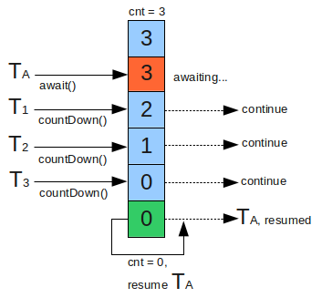
public CountDownLatch(int count) {...}
This count is essentially the number of threads, for which latch should wait. This value can be set only once, and CountDownLatch provides no other mechanism to reset this count.
The first interaction with CountDownLatch is with main thread which is goind to wait for other threads. This main thread must call, CountDownLatch.await() method immediately after starting other threads. The execution will stop on await() method till the time, other threads complete their execution.
Other N threads must have reference of latch object, because they will need to notify the CountDownLatch object that they have completed their task. This notification is done by method : CountDownLatch.countDown(); Each invocation of method decreases the initial count set in constructor, by 1. So, when all N threads have call this method, count reaches to zero, and main thread is allowed to resume its execution past await() method.

Fork/Join Framework: ForkJoinPool
The effective use of parallel cores in a Java program has always been a challenge. There were few home-grown frameworks that would distribute the work across multiple cores and then join them to return the result set. Java 7 has incorporated this feature as a Fork and Join framework.
Basically the Fork-Join breaks the task at hand into mini-tasks until the mini-task is simple enough that it can be solved without further breakups. It’s like a divide-and-conquer algorithm. One important concept to note in this framework is that ideally no worker thread is idle. They implement a work-stealing algorithm in that idle workers steal the work from those workers who are busy.

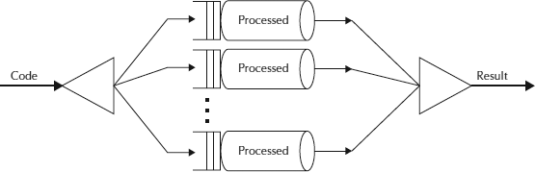

ForkJoinPool
The ForkJoinPool is basically a specialized implementation of ExecutorService implementing the work-stealing algorithm we talked about above. We create an instance of ForkJoinPool by providing the target parallelism level i.e. the number of processors as shown below:
ForkJoinPool pool = new ForkJoinPool(numberOfProcessors);
Where numberOfProcessors = Runtime.getRunTime().availableProcessors();
If you use a no-argument constructor, by default, it creates a pool of size that equals the number of available processors obtained using above technique.

Lock Reentrance
Synchronized blocks in Java are reentrant. This means, that if a Java thread enters a synchronized block of code, and thereby take the lock on the monitor object the block is synchronized on, the thread can enter other Java code blocks synchronized on the same monitor object. Here is an example:
public class Reentrant{

public synchronized outer(){
inner();
}

public synchronized inner(){
//do something
}
}
Notice how both outer() and inner() are declared synchronized, which in Java is equivalent to a synchronized(this) block. If a thread calls outer() there is no problem calling inner() from insideouter(), since both methods (or blocks) are synchronized on the same monitor object ("this"). If a thread already holds the lock on a monitor object, it has access to all blocks synchronized on the same monitor object. This is called reentrance. The thread can reenter any block of code for which it already holds the lock.
The lock implementation shown earlier is not reentrant. If we rewrite the Reentrant class like below, the thread calling outer() will be blocked inside the lock.lock() in the inner() method.

What is Reflection API
diff between Callable and Runnable interface
Callable | Runnable
Checked Exception | throw Checked Exception | Does not throw Checked Exception
Return value | Yes | No
Implementation method | call() | run()
Availability | Java 5 | Since jdk 1.0 i.e from beginning

1. Checked Exception : Callable's call() method can throw checked exception while Runnable run() method can not throw checked exception.

2. Return value : Return type of Runnable run() method is void , so it can not return any value.
while Callable can return the Future object, which represents the life cycle of a task and provides methods to check if the task has been completed or canceled.

3. Implementation : Callable needs to implement call() method while Runnable needs to implement run() method.
public interface Runnable {
void run();
}
public interface Callable<V> {
V call() throws Exception;
}

4. Availability : Runnable is available in java right from JDK 1.0 while Callable was later added to JDK 5.

5. Execution : Limitation of Callable interface lies in java is that one can not pass it to Thread as one pass the Runnable instance. There is no constructor defined in the Thread class which accepts a Callable interface.

Reentrant locks
The traditional way to achieve thread synchronization in Java is by the use of synchronized keyword. While it provides a certain basic synchronization, the synchronized keyword is quite rigid in its use. For example, a thread can take a lock only once. Synchronized blocks don’t offer any mechanism of a waiting queue and after the exit of one thread, any thread can take the lock. This could lead to starvation of resources for some other thread for a very long period of time.
Reentrant Locks are provided in Java to provide synchronization with greater flexibility.
What are Reentrant Locks?
The ReentrantLock class implements the Lock interface and provides synchronization to methods while accessing shared resources. The code which manipulates the shared resource is surrounded by calls to lock and unlock method. This gives a lock to the current working thread and blocks all other threads which are trying to take a lock on the shared resource.
As the name says, ReentrantLock allow threads to enter into lock on a resource more than once. When the thread first enters into lock, a hold count is set to one. Before unlocking the thread can re-enter into lock again and every time hold count is incremented by one. For every unlock request, hold count is decremented by one and when hold count is 0, the resource is unlocked.
Reentrant Locks also offer a fairness parameter, by which the lock would abide by the order of the lock request i.e. after a thread unlocks the resource, the lock would go to the thread which has been waiting for the longest time. This fairness mode is set up by passing true to the constructor of the lock.

Why wait and notify needs to be called from synchronized context
We use wait(), notify(), or notifyAll() method mostly for inter-thread communication in Java. One thread is waiting after checking a condition e.g. In the classic Producer-Consumer problem, the Producer thread waits if the buffer is full and Consumer thread notify Producer thread after it creates a space in the buffer by consuming an element.
Calling notify() or notifyAll() methods issues a notification to a single or multiple thread that a condition has changed and once notification thread leaves synchronized block, all the threads which are waiting fight for object lock on which they are waiting and lucky thread returns from wait() method after reacquiring the lock and proceed further.
What is race condition?
Race condition in Java is a type of concurrency bug or issue which is introduced in your program because parallel execution of your program by multiple threads at same time, Since Java is a multi-threaded programming language hence risk of Race condition is higher in Java which demands clear understanding of what causes a race condition and how to avoid that. AnywayRace conditions are just one of hazards or risk presented by use of multi-threading in Java just like deadlock in Java. Race conditions occurs when two thread operate on same object without proper synchronization and there operation interleaves on each other. Classical example of Race condition is incrementing a counter since increment is not an atomic operation and can be further divided into three steps like read, update and write. if two threads tries to increment count at same time and if they read same value because of interleaving of read operation of one thread to update operation of another thread, one count will be lost when one thread overwrite increment done by other thread. atomic operations are not subject to race conditions because those operation cannot be interleaved

What is concurrency?

what is producer and consumer problem? explain with realtime example.
What is optimistic locking?
WeakHashMap
ACID properties
Volatile keyword and its importance
Major differences between java1.5 and java1.6
What is generics?
What generic changed underleying JVM processs?
Diff between StringBuilder and StringBuffer
Diff between concurrenthasmap and Synchronize concurrent hashmap?
Does String has reverse() function?
Why notigy,notifyAll methods defined at Object level but not thread level?
How many ways you can reverse a string and which one is efficient?
Datastructures: Stack, Queue, LL, Trees,Graphs
Diff between synchronized block and synchronized method?
What is SecurityManager?
What is Thread dump?

Others:
Which keyword is invalid for a default constructor - public, private, final and static --> final and static can't apply(Invalid)
Hierarchy of an object creation in inheritance?

how to improve application performance
which application server u have worked on?
How to design an application which allows access 1Lack users at a time?
How to improve performance of an application?
What is connection pooling and how to achieve it?
XPATH
How to improve code quality?
Which collection class should I use to maintain student rolno unique in the collection? Student model has sid, sname;
To design Amazon product page, how will you design and how to pull the products when you scroll down and scroll up.
What is load the balancer?
Which application server you have used?
Is tomcat is an application server? - It is a web server(has only ServletContainer) and not full flexed application server
How tomcat server differe multiple requests?
How to improve performance of an application?
What design patterns used in your projects
Have you implemented any design pattern other than spring framework inbuilt DPs?
What design principles you know
What are the technical design principles implemented for your solution?
What are the SOLID principles? --> what is single responsibility?
What are the design guidelines?
What are the design patterns which you have used in your recent project?
What is the most complex task developed by you?
How Tomcat server differentiate each request coming in?

What are the drawbacks of your solution(Commonservice)? --> If it down then all applications down (Single point of failure)?
How will you do code review?
What techniques, will u use for code review?
What is spring boot?
What is microservices?
What is the complext tasks which you have done?
How will you do deployment?
How to perform integration test?
How to mock object in the prodution? After deployment, we dont test with actual data insted will do mocking object. How to do it?
Test Driven Development and what tools need to use
How do you implement user accessability
Agile development
What are the code review principles you follow?
What is Load balancer?
What is Mongodb?
Hands on experience on Mongodb.
Experience on Search enginee optimization
What is 403 error from server?

JUnit:
What is JUnit?
What is the test life cycle in JUnit?
How to perform integration test in Junit?

Design Patterns:
Observer design pattern
Diff between Proxy and Decorator design pattern
AbstractFactory
Proxy design pattern

Devops:
What is build pipeline?
Automation build tool
What is Docker?
What is the build pipeline?
Automaion build tools: Maven & jenkins
What kind of containers do u use?

Preparation:
- When will you get StackOverFlow exception?
In recursive, a function calling itself continuously without breaking then it will throw StackOverFlow exception
public void mymethod() {
Interface2.super.mymethod();
}

